Preparing the Organization for Business Growth

Presented at Montessori Alliance of Tennessee
September 2015 Conference

By
Brenda O. Bernstorf, Deputy Executive Director
Montessori Academy, Inc.

Contact Information:

Email: bbernstorf@montessoriacad.org
Phone: 615-833-3610

Introduction

Here are some startling facts:
- 26% of Employees are engaged
- 74% of employees are either indifferent or actively disengaged
- 18% of these are actively disengaged AND intentionally acting in ways that negatively impact their organizations.
- Companies with double-digit growth have: (Hewitt Associates)
  - Senior leaders who are 25% more engaged than their employees and more engaged than leaders in single-digit growth organizations
  - Senior leaders who are passionate about creating a positive work environment & culture
  - Senior leaders who instill pride and engendered a growth mindset in their employees
  - Senior leaders who provided greater opportunities for support and development

CORE CULTURE = PURPOSE + PHILOSOPHY + PRIORITIES

- PURPOSE
Purpose is the fundamental reason why the organization exists. Purpose unites efforts and inspires action. The purpose is the compass that provides direction – even when there is no end in sight. Purpose tells us why what we are doing is important. The purpose acts as a magnet to draw people together to make an impact on our world.

The Purpose defines why your organization exists.

- PHILOSOPHY
The philosophy is the central character of the organization and the organizing principle for how business is conducted. It is the organization’s distinctive feature and the prime attribute that members believe set it apart from the competition.

- PRIORITIES
Priorities are the values and directions that guide the work. You have to find the priorities that effectively support the purpose and philosophy. It will take these priorities to achieve your goals.

Priorities changes as there is need. Purpose and Philosophy don’t change unless the organization is looking for a revolutionary change.

CORE CULTURE = PURPOSE + PHILOSOPHY + PRIORITIES

Everyone needs to connect to the CORE – understand the core – it is fundamental to creating a workplace that is the right place – a workplace that feels like home.

- MISSION
Your mission statement should inspire you and your employees and is at the center of the process of what you do. It should:
- Be 1 sentence long – Abraham Lincoln’s mission was to preserve the Union; FDR’s was to end the Depression
- Easily understood by a 12-year old – make it simple.
- It should be easily remembered and recited by memory at gunpoint. [We must understand the urgency and importance of our mission if we want to fulfill it.]

To create your mission statement:
- List three verbs about the actions you want to take…my mission is… verb, verb, and verb.
- Add your core value or values
- Determine Who (the group of people) you want to serve.

Our mission is to cultivate a love for learning through academic excellence in a nurturing, authentic Montessori environment. [for children is understood]

Our mission as an employer is to promote professional excellence in a supportive and excelling community of professionals.

THE IMPORTANCE OF THE MISSION IS TO KEEP THE ORGANIZATION ON TASK.

- PRACTICES

- Internal Practices – define how you interact with employees
- External Practices – define how you interact with customers

- PROJECTIONS
- Your name (AND Reputation)
- Your logo
- Your location
- The appearance of your facilities
- Your manner of dress
- Your advertising
- Your community activities

- VISION
The vision statement is the end result of what you will have done/completed. It will sustain you when the mission statement seems too heavy to endure, enforce, or engage. It should
- Be written down
- Should be in present tense (as if it has already been accomplished)
- It should be filled with descriptive details that anchor it to reality

- ENGAGEMENT

Employee engagement is the ability to capture the heads, hearts, and souls of your employees to instill an intrinsic desire and passion for excellence. Engaged employees want their organization to succeed because they feel connected emotionally, socially, and even spiritually to its mission, vision, and purpose. Fleming & Asplund

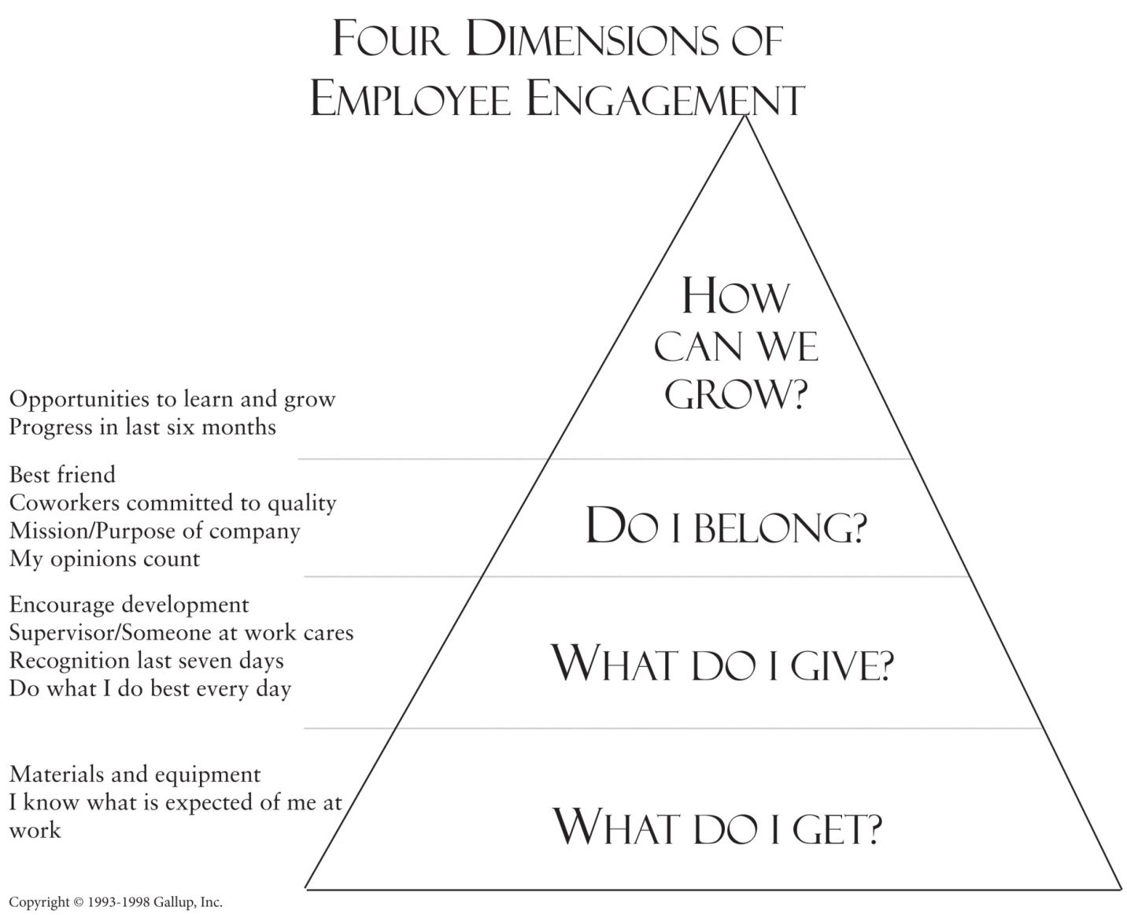

- 26% of Employees are engaged
- 74% of employees are either indifferent or actively disengaged
- 18% of these are actively disengaged AND intentionally acting in ways that negatively impact their organizations.

References

Averill, J. R. (2002). Chapter 13: Emotional Creativity: Toward “Spiritualizing the Passions”. Handbook of Positive Psychology, Ed.Snyder, C. R. & Lopez, S. J. New York, NY. Oxford University Press.

Colan, L. J. (2009). Engaging the Hearts and Minds of all your Employees, New York, NY, McGraw Hill.

Fleming, J. H. & Asplund, J. (2007). Human Sigma. New York, NY, Gallup Press.

Jones, L. B., (1996). The Path: Creating Your Mission Statement for Work and for Life, New York, NY, Hyperion.

Margolis, S. L. & Wilensky, A. S. (2006). There is No Place Like Work: Seven Leadership Insights for Creating a Workplace to Call Home. Salt Lake City, UT, Gibbs Smith, Publisher.

