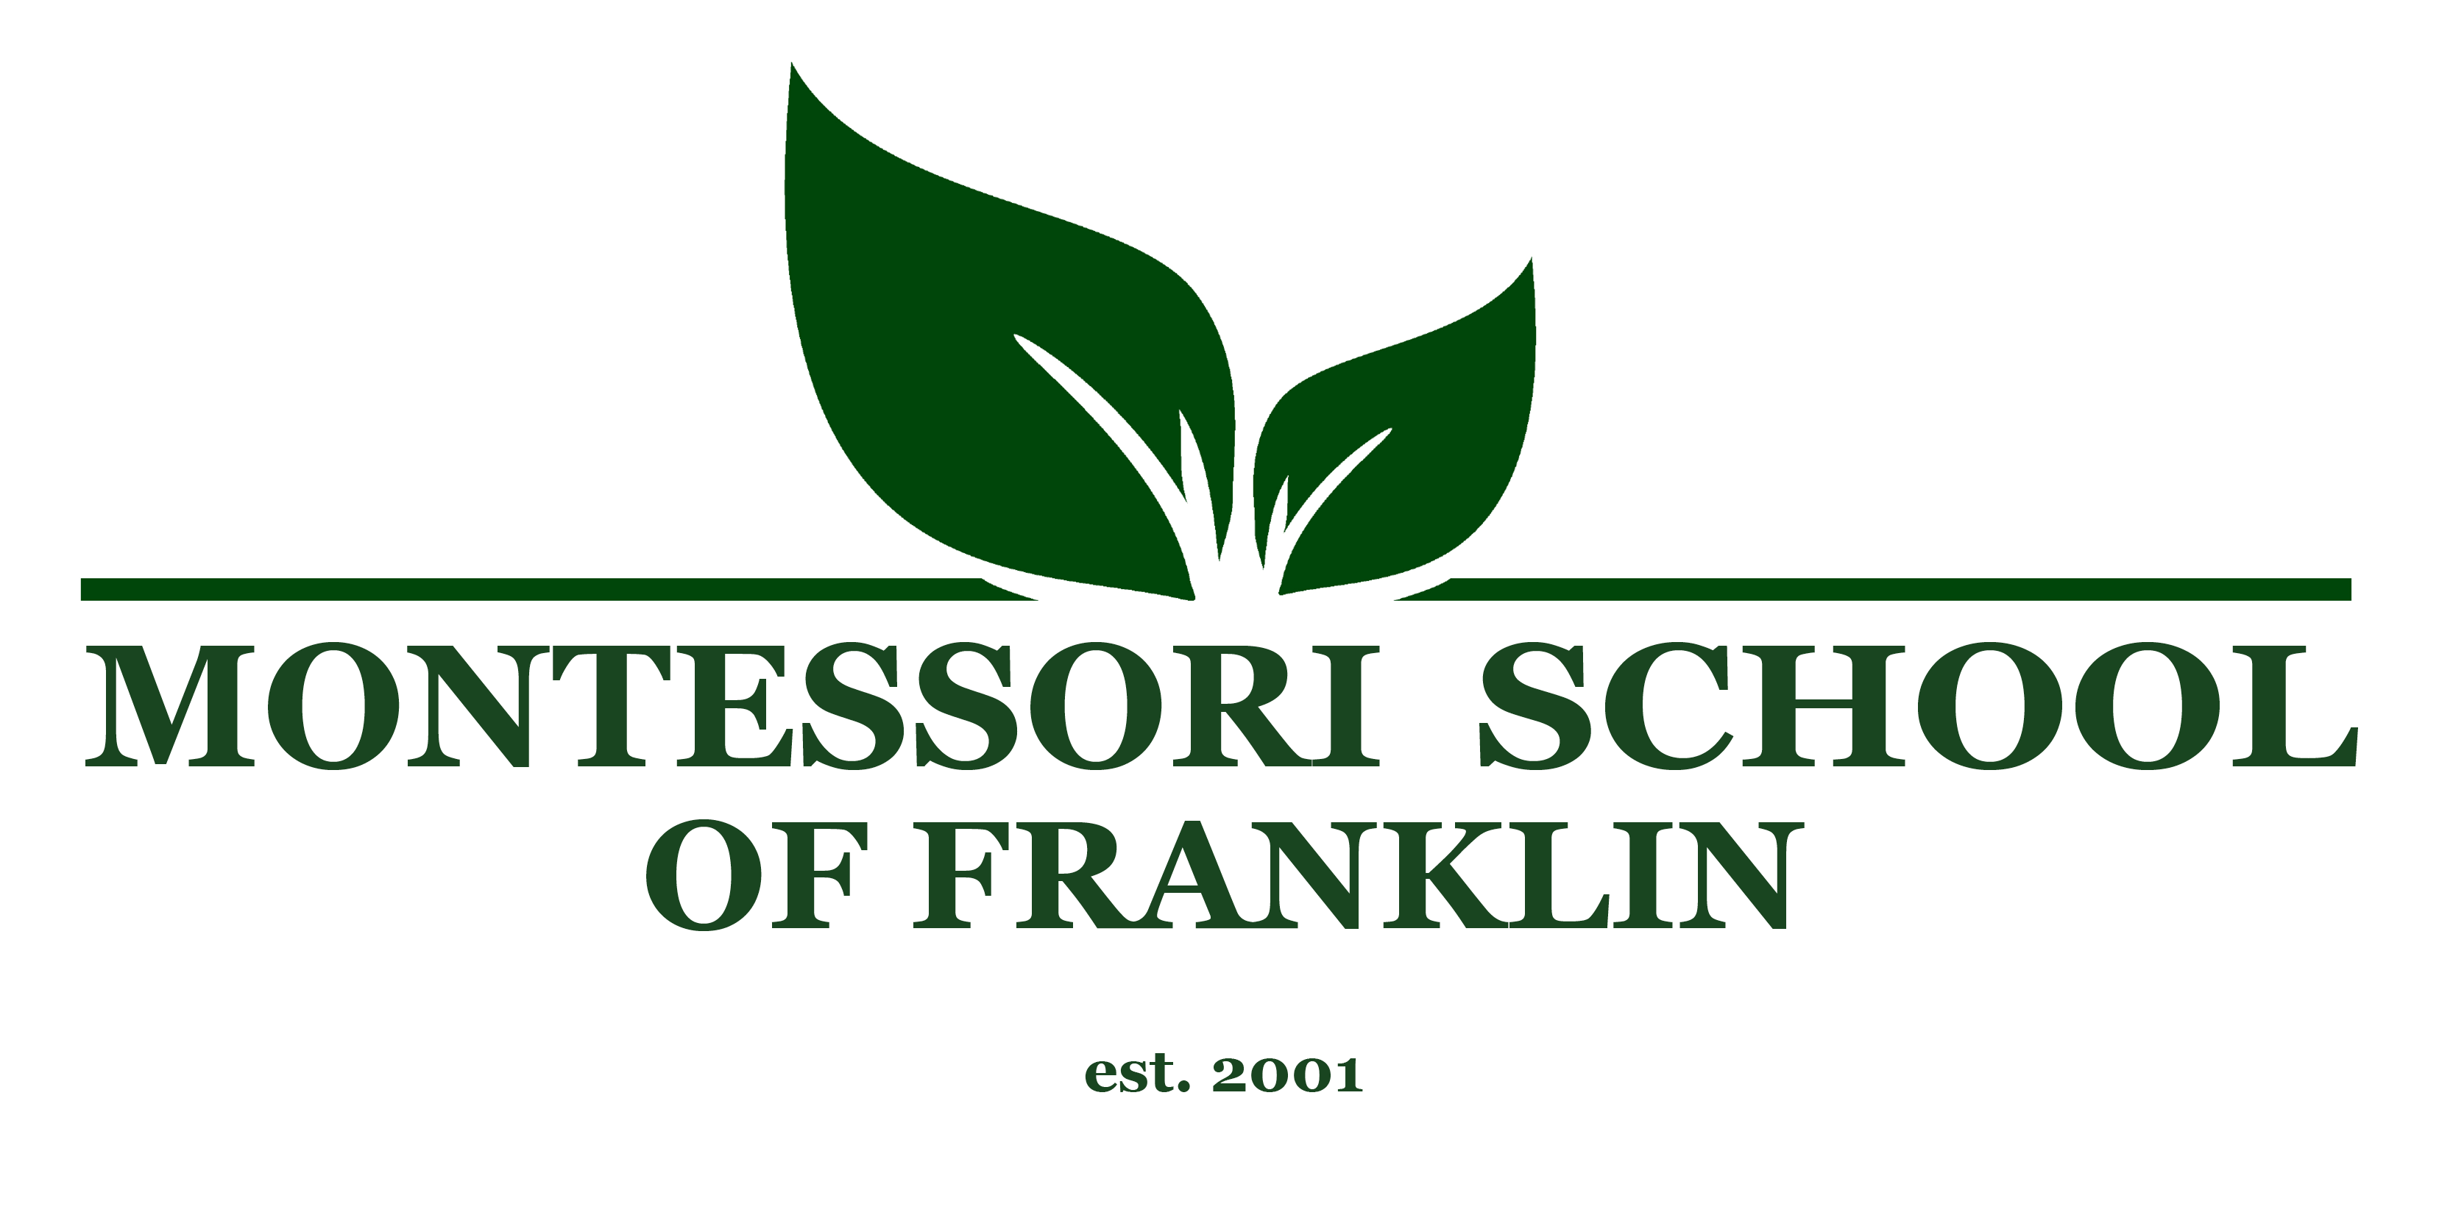
Primary Assistant
Montessori School of Franklin is a nonprofit Montessori School established in 2001 by a group of parents. We are a community of children, parents, and staff dedicated to following the development of the whole child. Montessori School of Franklin is seeking a full time Primary Assistant who will work closely with our Primary Lead in guiding our 3-6 year old classroom. We are looking for a candidate that will uphold the true ideological beliefs of Maria Montessori and exemplify kindness, trust, courtesy, independence, and striving to better ourselves and our community commitment. Ideal candidates must have a high school diploma (or higher), childcare experience (preferably Montessori), and a willingness to be a representation of the Montessori Method. Job duties include but are not limited to being prepared to work closely with the lead as a balanced team and acting as the lead’s “right hand man”, managing the classroom environment, being a firm yet loving presence, and upholding a calm, patient environment. To apply, please send a cover letter and a resume to ramona@montessorifranklin.org.
Phone: 615-794-0567
Address: 4321 Long Lane
Franklin, TN 37064

